INTERNET OF THINGS PROJECT

IOT PROJECT ON OBSTACLE SENSOR

YEAR:2019-20

DONE BY: DHARSHINII.R

REFFERED FROM: <https://create.arduino.cc/projecthub/Raushancpr/arduino-with-ir-sensor-1579b6>

IOT PROJECT ON OBSTACLE SENSOR

REQUIREMENTS:

* INFRA RED PROXIMITY SENSOR
* Arduino UNO
* LED
* ADUINO CABLE
* BREADBOARD
* CONNECTING WIRES

CONNECTIONS:

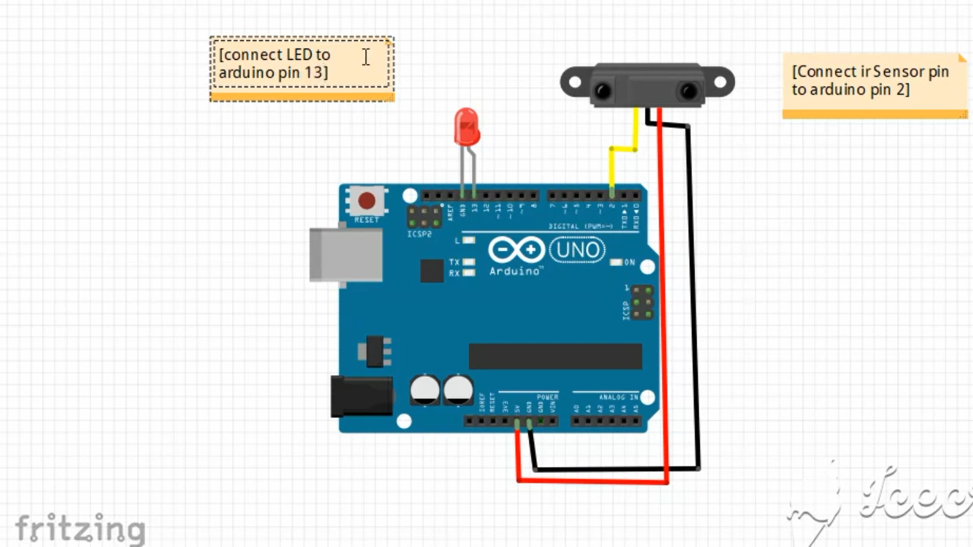

PROGRAM:

int IRSensor = 2; // connect ir sensor to arduino pin 2

int LED = 13; // conect Led to arduino pin 13

void setup()

{

pinMode (IRSensor, INPUT); // sensor pin INPUT

pinMode (LED, OUTPUT); // Led pin OUTPUT

}

void loop()

{

int statusSensor = digitalRead (IRSensor);

if (statusSensor == 1)

digitalWrite(LED, LOW); // LED LOW

}

else

{

digitalWrite(LED, HIGH); // LED High

}

}

OUTPUT:

